Creat a new table

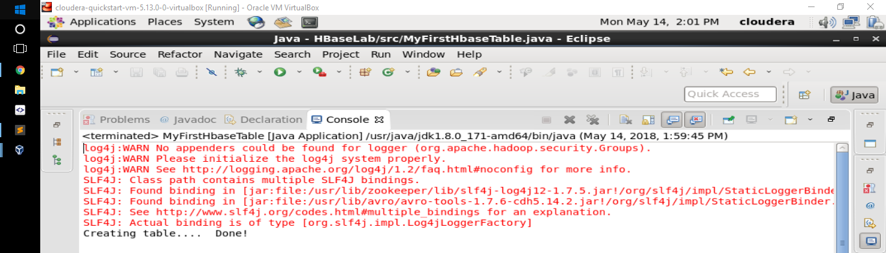

Here is the result when run ***list*** command

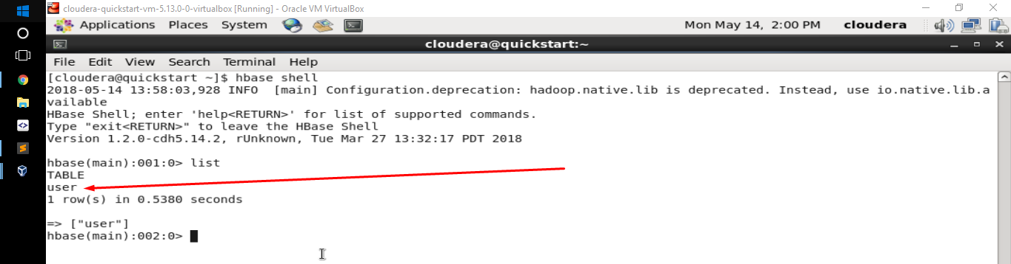

Insert data to ***user*** table

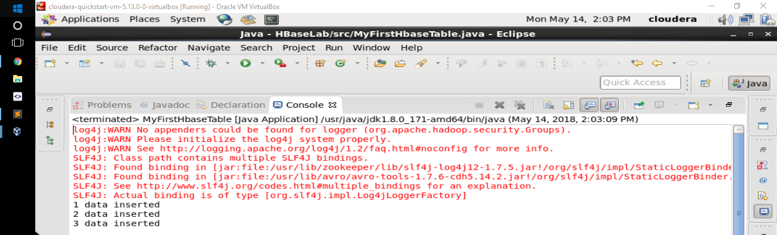

Run ***scan user*** command

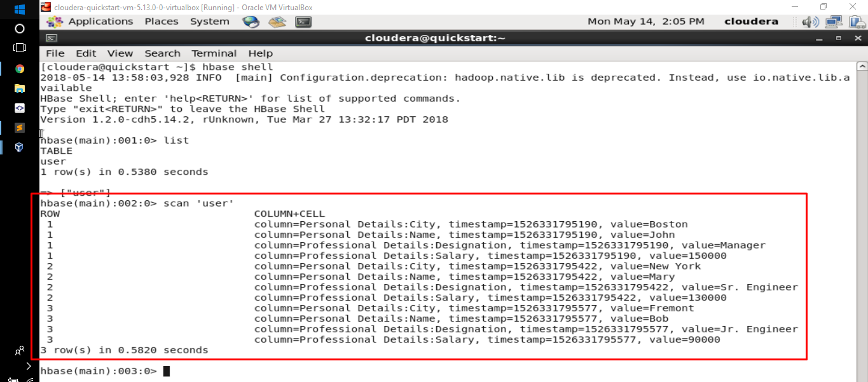

Update John’s salary to 160,000

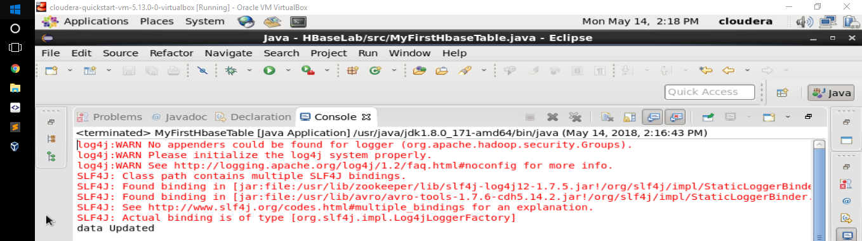

Run **scan user** command

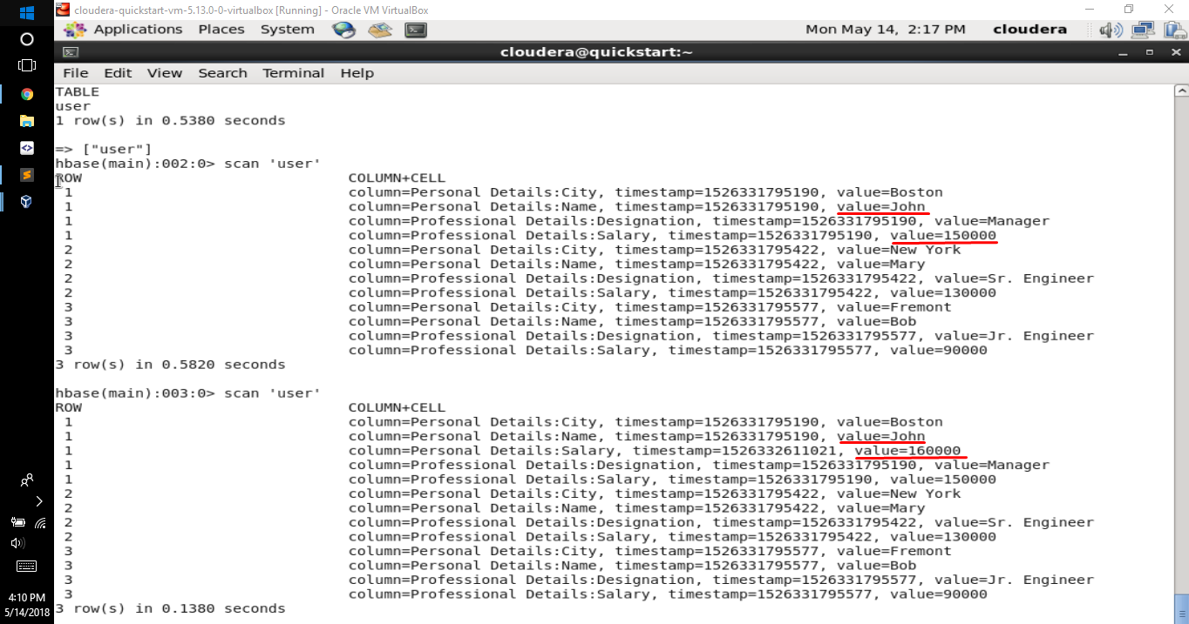

Get number of row in ***user*** table

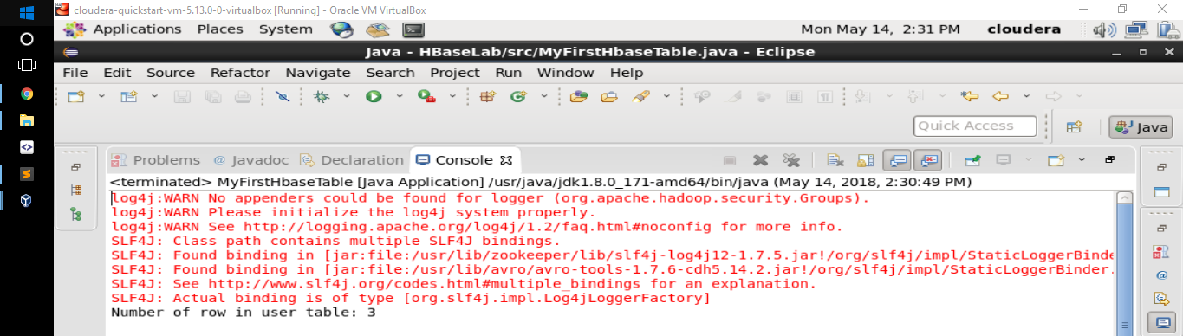

Or we can run **count** command in shell

